NFC-IET UNIVERSITY, MULTAN



LAB REPORT

ICT (“Information & Communication Technology Fundamental”)

## For the degree of Bacheller of Science

In Computer Science

Session [2k24]

**Name : Yasir Rasheed**

**Roll no : (2k24-BSSE-226)**

**Section : (B)**

### Submitted To: Fabiha Hassan

### Submitted By: Yasir Rasheed

**Date:** **11 December 2024**

## **LAB #01**

## **Typing Practices (Typ**ing Tutor)

## A **typing tutor**, is a structured way to improve typing speed and accuracy. Typing tutors are software or online platforms designed to teach and help users develop better keyboarding skills. These tools are essential for improving typing efficiency and reducing errors.

## **Key Components of Typing Practice:**

## **Home Row:**

## The central row of keys where fingers should rest, which includes the letters A, S, D, F, J, K, L, ;.

## Proper finger placement on the home row keys is essential for efficient typing.

## **Fingers and Key Positioning**:

## **Left Hand**: A, S, D, F (pinky on A, ring finger on S, middle finger on D, index on F)

## **Right Hand**: J, K, L, ; (pinky on ;, ring finger on L, middle finger on K, index on J)

## **Thumbs**: Used for the spacebar.

## **Proper Posture**:

## Sit straight with feet flat on the ground.

## Maintain your wrists level with the keyboard to avoid strain.

## Keep fingers relaxed but ready to type.

## **Keying Exercises**:

## **Typing Drills**:

## Repeated exercises focusing on specific keys, combinations, or common words.

## **Speed Building**: Gradual increase in the difficulty of typing exercises to increase typing speed while maintaining accuracy.

## **Accuracy Focus**: Regular drills that focus on minimizing errors by slowing down the typing speed.

## **Typing Tests**: These are timed sessions where you type a passage or a series of words, and the software measures your accuracy and words per minute (WPM). This helps gauge improvement.

**Internal Components of a Computer (Recognition and Understanding)**

The internal components of a computer refer to the hardware and circuitry that work together to perform tasks and processes. Understanding these components is vital for anyone interested in how a computer functions.

**Key Internal Components:**

1. **Central Processing Unit (CPU)**:
   * **Function**: The CPU is often called the "brain" of the computer. It carries out instructions from programs by performing basic arithmetic, logic, control, and input/output operations.
   * **Parts**:
     + **ALU (Arithmetic Logic Unit)**: Handles arithmetic and logical operations.
     + **Control Unit (CU)**: Directs the operation of the processor by interpreting instructions.
     + **Cache**: A small, high-speed storage area located close to the CPU, storing frequently accessed data.
2. **Motherboard**:
   * **Function**: The motherboard is the main circuit board that holds the CPU, memory, and essential components. It also provides connectors for other peripherals.
   * **Ports and Slots**: Includes USB ports, Ethernet ports, PCI slots for expansion cards, and more.
   * **Chipsets**: Determines how data is transmitted between the CPU, memory, and other components.
3. **Memory (RAM)**:
   * **Function**: Random Access Memory (RAM) is a temporary storage area that holds data and instructions that the CPU is currently processing.
   * **Characteristics**: It is volatile, meaning it loses its content when the computer is turned off.
4. **Storage Devices**:
   * **Hard Disk Drive (HDD)**: A traditional storage device that uses spinning disks to read/write data. It offers large storage capacity but slower speeds compared to SSDs.
   * **Solid State Drive (SSD)**: A faster storage device that uses flash memory. SSDs are more reliable and faster but may have a lower capacity for the price.
   * **Optical Drives**: CD/DVD drives, though becoming less common in modern computers.
5. **Power Supply Unit (PSU)**:
   * **Function**: The PSU converts electrical power from an outlet into the appropriate voltage and current needed by the internal components of the computer.
6. **Graphics Processing Unit (GPU)**:
   * **Function**: The GPU handles rendering images and videos. It is especially important for gaming, video editing, and graphics-intensive tasks.

|  |  |  |
| --- | --- | --- |
| **Component** | |  | | --- | | **Function** | |
|  |  |

* + **Integrated vs. Dedicated GPUs**: Integrated GPUs share resources with the CPU, while dedicated GPUs have their own memory and are more powerful.

1. **Cooling System**:
   * **Fans**: Most computers have fans to keep the internal components from overheating.
   * **Heat Sinks**: A metal component that dissipates heat away from components like the CPU

**Input/Output Devices (I/O)**:

* **Input**: Devices like the keyboard, mouse, microphone, and camera that allow the user to interact with the computer.
* **Output**: Devices like monitors, speakers, and printers that allow the computer to provide feedback to the user.

|  |  |
| --- | --- |
| **CPU (Processor)** | Executes instructions; the "brain" of the computer. |
| **Motherboard** | The main circuit board that connects all components. |
| **RAM (Memory)** | Temporary memory for running applications. |
| **Storage** | Long-term data storage (HDD, SSD). |
| **Power Supply Unit** | Converts electricity to power the computer. |
| **Cooling System** | Keeps components from overheating (fans, liquid cooling). |
| **GPU (Graphics Card)** | Handles visual output for monitors and video processing. |
| **I/O Ports** | Connects peripherals like USB devices, monitors, and audio systems. |

**LAB #02**

## **Objective:**

## Understand the process of assembling a computer and installing Windows.

## **Part 1: CPU Assembly**

## **Step 1: Components**

## **Motherboard**:

## It is the the main circuit board.

## **CPU (Processor)**:

## It is the "brain" of the computer.

## **RAM (Memory)**:

## It stores the temporary storage for running programs.

## **Power Supply Unit (PSU)**:

## It provides power to all components.

## **Storage (SSD/HDD)**:

## It Stores the operating system and files.

## **Cooling System**:

## It Keeps the CPU cool.

## **PC Case**:

## It Encloses and protects the components.

## **Step 2: Assemble the Components**

## **Install the CPU**:

## Open the CPU socket on the motherboard.

## Align the CPU correctly (match the triangle marks).

## Place and secure the CPU.

## **Apply Thermal Paste and Install the Cooler**:

## Apply a small amount of thermal paste on the CPU.

## Attach the CPU cooler securely and connect its cable to the motherboard.

## **Install RAM**:

## Insert RAM sticks into the motherboard slots (push until they click).

## **Mount Motherboard and Connect PSU**:

## Secure the motherboard inside the PC case with screws.

## Connect power cables from the PSU to the motherboard and other components.

## **Install Storage and Connect Front Panel Cables**:

## Mount SSD/HDD and connect to the motherboard.

## Attach the front panel cables (power button, USB, etc.) to the motherboard.

## **Step 3: Verify Connections and Power On**

## Double-check all connections.

## Power on the system to ensure it works.

## **Windows Installation**

## **Step 1: Create a Bootable USB**

## Download the Windows ISO file from Microsoft’s website.

## Use a tool like **Rufus** to create a bootable USB drive.

## **Step 2: Boot from USB**

## Insert the USB into the PC.

## Enter BIOS/UEFI by pressing DEL, F2, or F12 during startup.

## Set USB as the first boot device.

## **Step 3: Install Windows**

## Follow the on-screen instructions:

## Select language, time, and keyboard preferences.

## Click **Install Now**.

## Enter the product key or skip.

## Choose **Custom Installation** to select a drive for Windows.

## Partition the drive if necessary and start installation.

## **Step 4: Complete Setup**

## After installation, set up your account, region, and privacy settings.

## **Post-Installation Tasks**

## **Install Drivers**: For motherboard, GPU, and peripherals.

## **Update Windows**: Install the latest updates.

## **Configure Basic Settings**: Personalize display, sound, and network settings.

CPU Assembling

Assembling a CPU (Central Processing Unit) and its associated components is an essential skill for understanding how computers function. This task will enhance your hands-on knowledge of hardware assembly.

Component

• Processor (CPU)

• Motherboard

• RAM

• Power Supply Unit (PSU)

• Storage Device (HDD/SSD)

• Cooling System (Heatsink/Fan)

**Assembly Process**

1. **Installing the Processor**:
   * Unlocked the CPU socket and placed the processor carefully.
   * Secured it with the retention arm.
2. **Mounting RAM**:
   * Inserted the RAM module into the designated slot.
3. **Connecting PSU and Storage**:
   * Connected power cables and SATA cables properly.
4. **Testing**:
   * Booted the system and accessed the BIOS.

**Challenges Faced**

* Difficulty installing the CPU fan, but resolved by following the motherboard manual.

LAB #03

**Motherboard and Its Internal Structure**

**Motherboard Components Identification**

**Key Components and Their Functions**

1. **CPU Socket**
   * This is where the CPU is installed. It connects the processor to the rest of the motherboard, enabling communication and power delivery.
2. **RAM Slots**
   * These slots hold the RAM modules. They allow the system to temporarily store data that the CPU frequently accesses.
3. **Power Connectors (24-pin and 8-pin)**
   * These connectors supply power to the motherboard and CPU.
4. **SATA Ports**
   * Used to connect storage devices like HDDs and SSDs.
5. **Battery**
   * It powers the BIOS firmware, ensuring system settings like date and time are retained even when the PC is turned off.
6. **I/O Ports**
   * Include USB, Ethernet, HDMI, and audio ports to connect external devices.

**Internal Structure and Functionality**

**Internal Structure**

The motherboard serves as the central hub of the computer, linking all its components together. Here’s how the interaction works:

* **CPU and RAM**: The CPU fetches instructions and data from the RAM via the motherboard. This allows high-speed communication for efficient processing.
* **Storage and CPU**: Data from the storage devices is transferred to the CPU for processing via the SATA interface or PCIe (for NVMe SSDs).
* **Chipset**: Acts as a controller, ensuring smooth data transfer between all components.

**Bus Systems**

1. **Data Bus**: Transfers actual data between components.
2. **Address Bus**: Carries the memory addresses where data is to be read or written.
3. **Control Bus**: Manages commands and responses between components.

**Power Distribution**

The motherboard receives power from the PSU through the 24-pin and 8-pin connectors. This power is then distributed to all components, ensuring stable operation.

**Expansion Slots**

The PCIe slots allow users to enhance the system's capabilities by adding components like GPUs, sound cards, or additional storage.

LAB #04

**Introduction to MS Office and MS Word Basic Features**

**Introduction to MS Office**

Microsoft Office is a suite of productivity applications that are widely used in both personal and professional settings. It includes several tools such as **MS Word**, **MS Excel**, **MS PowerPoint**, **MS Access**, and **MS Outlook**, among others. These tools help users to create documents, manage data, make presentations, and handle emails efficiently.

MS Office is user-friendly and offers a variety of templates and features that simplify complex tasks, making it an essential tool for students and professionals alike.

**MS Word: Basic Features**

Microsoft Word is a word processing application that allows users to create, edit, and format text documents. Below are some of its basic features:

1. **Creating and Saving Documents**
   * Users can create new documents and save them in various formats such as .docx or .pdf.
2. **Formatting Text**
   * MS Word allows users to change the font style, size, and color of the text.
   * Options like **bold**, **italic**, and **underline** enhance the appearance of the text.
3. **Paragraph Formatting**
   * Features like alignment (left, center, right, justify), line spacing, and indentation help organize the content neatly.
4. **Insert Features**
   * **Images**: Users can insert pictures and shapes to make the document more visually appealing.
   * **Tables**: MS Word allows the creation of tables to organize data.
   * **Headers and Footers**: Users can add headers and footers to display titles, page numbers, or dates on every page.
5. **Spelling and Grammar Check**
   * MS Word automatically detects and highlights spelling and grammatical errors, providing suggestions for corrections.
6. **Page Layout**
   * Users can adjust margins, page orientation, and paper size to customize the document layout.
7. **Find and Replace**
   * This feature allows users to quickly locate specific words or phrases and replace them with new text.
8. **Printing**
   * MS Word offers various printing options, including selecting specific pages, adjusting print quality, and previewing the document before printing.

**FORMULAS**

* **• Addition: =A1 + A2**
* **• Subtraction: =A1 - A2**
* **• Multiplication: =A1 * A2**
* **• Division: =A1 / A2**
* **COUNT: Counts the number of cells containing numbers.**
* **Syntax: =COUNT(A1:A10)**

**• MAX: Returns the highest value from a range.**

* **Syntax: =MAX(A1:A10)**

**• MIN: Returns the lowest value from a range.**

* **Syntax: =MIN(A1:A10)**

**LAB # 05**

**MS word Advanced features**

**Subject: Job Offer Confirmation**

**Dear John,**

**We are pleased to offer you the position of Marketing Assistant at ABC Company, starting on December 1, 2024. You will report to Ms. Jane Doe. Your salary will be $45,000 per year, with benefits as discussed.**

**Please confirm your acceptance by signing below. We look forward to working with you!**

**Sincerely,**

**Sara**

**HR Johnson**

**ABC Company**

**STEPS FOR MAIL MERGE**

**Step 1: Prepare Your Data Source**

• Create a data file containing the information you want to merge. This can be a table in:

Microsoft Excel: Create a spreadsheet with column headers like "Name,"

"Address," etc.

• Microsoft Access or a simple Word Table.

Save your data source.

**Step 2: Open Microsoft word**

* **Open a blank Document or exisiting template or letter,label,or email.**

**Step 3: Start the Mail Merge Wizard**

**1. Go to the Mailings tab in the Ribbon.**

**2. Click on Start Mail Merge and select the type of document:**

**Letters**

**Email Messages**

**Envelopes**

**• Labels**

**Directory**

**Step 4: Select Recipients**

**1. Click Select Recipients in the Mailings tab.**

**2. Choose the source for your data:**

**• Type a New List: Create a list directly in Word**

**Use an Existing List: Browse to your Excel or Access file.**

**Select from Outlook Contacts.**

**Step 5: Insert Merge Fields**

**1. Place your cursor in the document where you want a personalized detail to appear.**

**2. Click Insert Merge Field in the Mailings tab.**

**3. Select fields like "Name," "Address," or others from your data source.**

**Step 6: Preview the Results**

**• Click Preview Results to see how your document will look with the data merged.**

**Step 7: Complete the Mail Merge**

**1. Click Finish & Merge in the Mailings tab.**

**2. Choose an option:**

**• Edit Individual Documents: Review and edit each document before finalizing.**

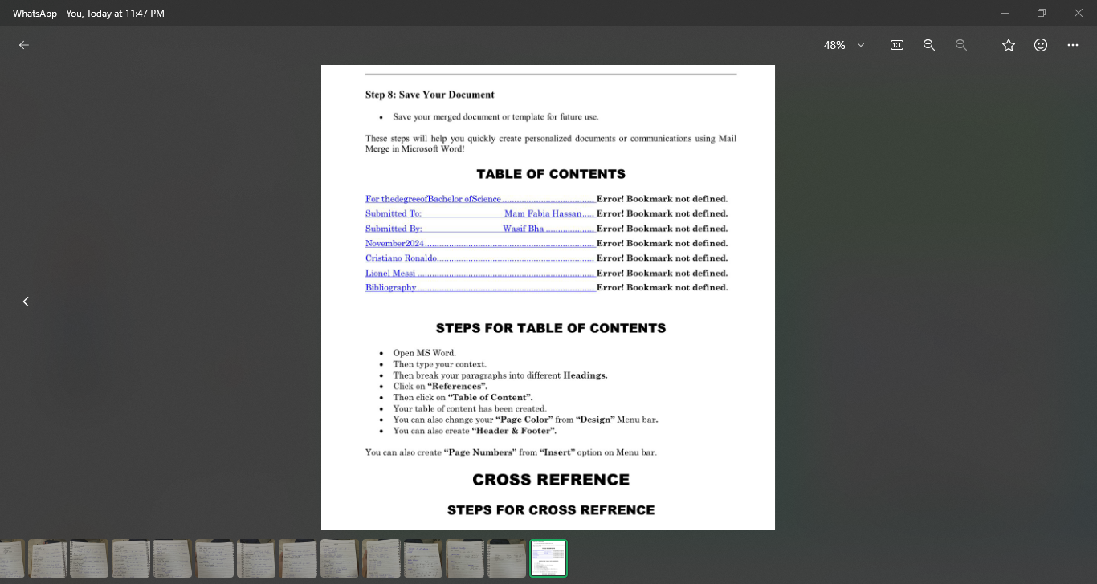

**• PLACE CURSOR WHERE YOU WANT TO ADD CROSS REFRENCE**

**GO TO REFRENCE TAB**

**• CLICK CROSS REFRENCE**

**• SELECT REFRENCE TYPE**

**• CHOOSE SPECIFIC REFRENCE FROM THE LIST**

**• CLICK INSERT**

**THERE ARE MANY GREAT FOOTBALL PLAYERS BUT MY FAVOURITES ARE :**

**• Cristiano Ronaldo**

**• Lionel Messi**

**• Bibliography**



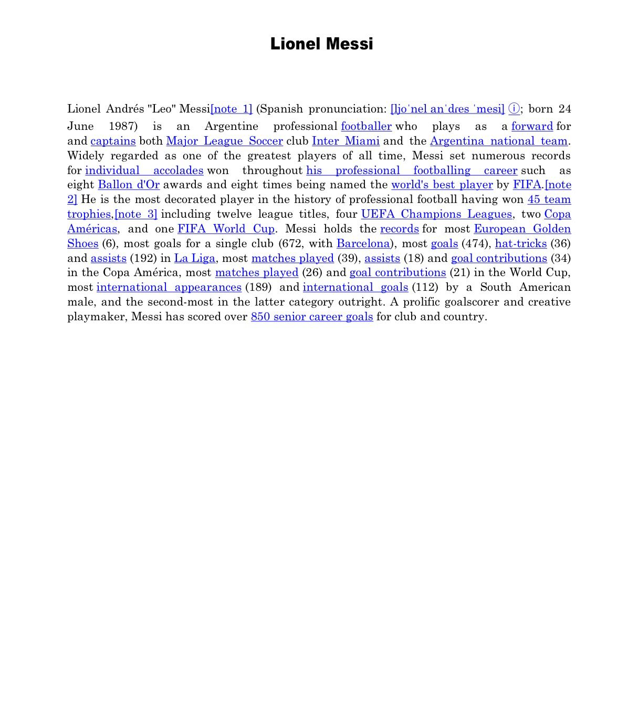

**Steps for bibliography**

**• Go to 'Refrence tab" Click "Bibilography"**

**• Select bibliography style**

**• Choose sources to include from your citation**

**• Click "OK"**

**LAB # 06**

**STEPS FOR MACROS**

**STEPS FOR MACROS**

**• GO TO VIEW TAB**

**• CLICK ON MACROS**

**• THEN SELECT RECORD MACROS**

**• ENTER MACRO NAME**

**• CHOOSE WORD MACROS AS THE LOCATION**

**• CLICK START RECORDING**

**PERFORM ACTION YOU WANT TO AUTOMATE**

**• CLICK STOP RECORDING**

**• GO TO VIEW TAB**

**• CLICK MACROS**

**• SELECT THE MACRO FROM THE LIST**

**'Macros are the recording of data in MS Word.**

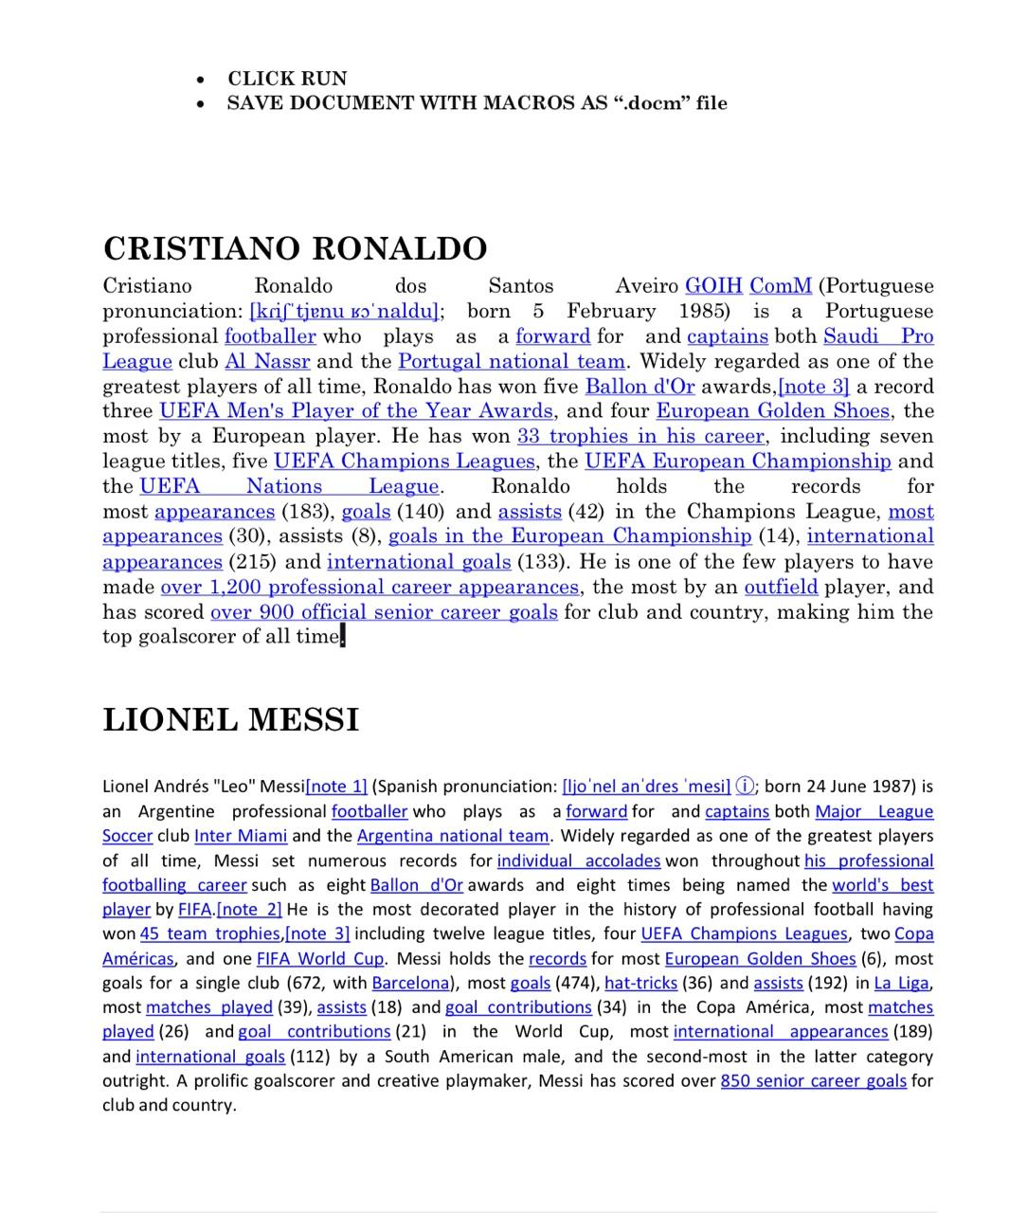

**STEPS FOR INSERT CITATION**

* Place the cursor where you want to add citation
* Go to refernce lab
* Click insert citation
* End source details

**LAB #07**

**How to Protect File and Password**

**STEPS FOR ADDING PASSWORD**

**OPEN DOCUMENT IN MS WORD**

**• GO TO "FILE > INFO"**

**• CLICK "PROTECT DOCUMENT"**

**• SELECT "ENCRYPT WITH PASSWORD"**

**• ENTER PASSWORD**

**• RE-ENTER PASSWORD TO CONTINUE**

**ClLICK OK**

**1. Mail Management**

* **Organizing Emails: Use folders, filters, and rules.**
* **Archiving and Searching: Efficiently store and retrieve emails.**

**2. Collaborative Tools**

* **Track Changes: Enable in MS Word to track edits and comments.**
* **Document Comparison: Compare multiple document versions.**
* **Real-Time Collaboration: Tools like Google Docs and OneDrive for teamwork.**

**3. Document Protection**

* **Password Protection: Restrict access using strong passwords.**
  + **Steps: File > Info > Protect Document > Encrypt with Password.**
* **Editing Permissions: Limit modifications (read-only, specific parts editable).**

**Practical Tasks**

1. **Enable Track Changes and add comments.**
2. **Protect a document with a password.**
3. **Use collaborative tools for real-time editing.**

**LAB # 08**

**FORMULA OF EXCEL**

**SUM FORMULA**

* **Open MS EXCEL**
* **Open New Sheet**
* **Merge and centre two or more row and columns and add heading of SUM**
* **Then make 2 or 3 columnefor items & price**
* **• After putting values we use formula = SUM (RANGE OF CELLS) and**
* **• the total is calculated at the point where we use formula.**

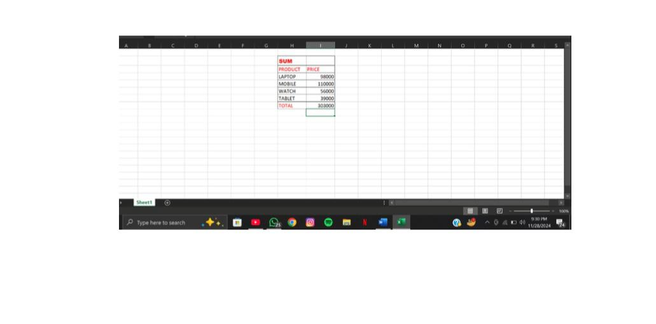

**PRODUCT FORMULA**

* **Open MS Excel**

**• Open a new sheet**

**• Merge & center 2 or more rows and columns for heading a formula "**

**PRODUCT "**

**• Then make 2 or 3 columns for items quantity and price**

**• Then put diff values in diff cells**

**• After putting values use formula =PRODUCT( range of cells) and then press enter**

**• The total is calculated where we have used the formula**

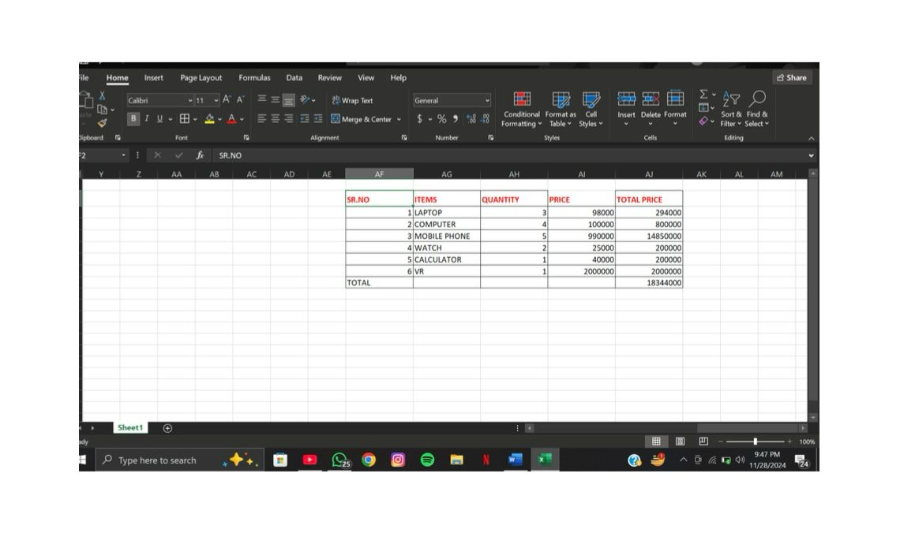

**PROPER FORMULA**

**• Open MS EXCEL**

**• Open a new sheet**

**• Merge and centre two or more row and columns and add heading of**

**Than make 2 or 3 columns for items & price**

**• Then put diff values in diff cells**

**• After putting values we use formula = PROPER (RANGE OF CELLS) and then press enter**

**The total is calculated at the point where we use formula**

